Guidance for formulating European Social Fund projects using the Logical Framework Approach

European Social Fund Agency Flanders

1. Introduction 3
2. Analysis 4
2.1 Describe the final target group. 4
2.2 Modalities with regard to involving stakeholders 5
2.3 Describe the problem by means of a problem analysis 7
2.4 Describe your strategic choices on the basis of an objective tree. 12
2.5. Situation of the project in the policy context 17
3. Formulation 18
3.1 Logical framework 18
3.2 Explanation of objectives 19
3.3 Substantiating the project logics from the logical framework 22
3.4 Assumptions 23
3.5 Explain indicators and objectively verifiable sources 25
3.6 Planning 27
3.7 Lessons/principles 30
3.8 Management 31
3.9 Evaluation 32
4. How to organise an efficient and successful process to prepare my project proposal 33
5. Reporting 36
5.1 Interim 36
5.2 Final 36
ANNEX 37
A. application form questions 37
C. Testing the quality of ESF project proposals 42
1. Relevance 44
2. Feasibility 50
3. Good project management 54

1. Introduction

This manual is aimed at submitters of project proposals for “outcome” oriented ESF calls.
- “Outcome” oriented calls refer to the achievement of wider, policy-relevant objectives. Solutions within the relevant policy domain are not determined by the call. Submitters can therefore think about and decide how to contribute to the policy objective.
- This is how they differ from “output” oriented calls where the call determined what the project must produce (outputs like training, processes for specific target groups).

The manual contains:
- An explication of the required steps and exercises which have to guarantee an optimal preparation of a successful project proposal.
- The assessment schemes as used by the judges. Submitters can anticipate the chances of success of their proposals by referring to these schemes.
- Which parts of a file provide input for which parts of the assessment.

The project proposal consists of different components:
- General questions to be filled in directly in the ESF application
- Questions in a content-related document to be uploaded in the ESF application divided in:
  - Analysis
  - Formulation
- Summary to be filled in directly in the ESF application
- Financial section to be filled in directly in the ESF application and in a spreadsheet to be uploaded.

This manual only covers the content document to be uploaded in the ESF application. For the other documents we refer to the specific provisions in the call document.

The manual also explains what the expectations are with regard to content-related reports.

For more information, contact Benedict Wauters at benedict.wauters@esf.vlaanderen.be

2. Analysis

2.1 Describe the final target group.

The final target group are the parties in whose interest the project will be implemented. Their situation is directly improved by means of access to and use of improved/new attitudes, practices, services and/or knowledge made available to them by the project.

A clear description of the final target group must elaborate on their relevant socio-economic roles/positions:
- training level/competences,
- health,
- income,
- age class,
- ethnic origin,
- geographic localization,
- nature and level of discrimination,
- features of jobs which are performed,
- family relations
- physical options

Information must also be provided about gender aspects (respective roles/positions of men and women).

The idea is not to describe the above features separately (like in a checklist), but rather to give an integrated description of the target group in which some aspects will be connected (e.g. metropolitan location and over-representation of deprived groups.

All this information is only useful if the relevance for the project can be demonstrated. This information should also make clear whether there are subgroups in the final target group which present differences which have to be taken into account in the project setup. It is not enough to list these features in a general way.

So: you should not only say “15% of our employees are immigrants", but make sure to explain that this is relevant "because some tension on the work floor stems from specific differences in cultural background" or "because some actions will have to be implemented differently with this subgroup.

If, based on this description, it turns out that relevant subgroups for the project exist within the target group, this must be clearly indicated.

e.g. it is possible that the project must make a distinction between lower-skilled employees and higher-skilled employees).

This must then be taken into account throughout the project proposal, more specifically when describing the problems, the formulation of the targets and the work programme.

During the next steps in the analysis (e.g. the problem tree) the description of the target group may have to be reviewed. This repetitive character of the analysis process is normal. For each step within the analysis the previous steps may be reviewed.

In summary, the project must elaborate on the most relevant features of the final target group (including gender aspects) with regard to their relevance towards the project and it must be possible to derive the subgroups from it. This will be the input for assessment criterion 1.1.

2.2 Modalities with regard to involving stakeholders

Stakeholders are all the groups, persons, institutions and/or organisations which are directly or indirectly ‘affected’ by the project and/or which can make a contribution to it.

This includes:

- the final target group (see above);
the intermediary target group: the stakeholders who must take part in the project because without them the improved/new attitudes, practices, services and/or knowledge will not be available for the final target group but who do not otherwise belong to the project team;
- the project team: those who will implement the project.

There are also other stakeholder organisations who are neither target group, nor implement the project, but who are nevertheless ‘affected’ by the project. These stakeholders can even be ‘negatively’ affected.

For instance, the final target group can consist of older employees. However, you must make sure that actions to the benefit of younger employees are not to the disadvantage of younger colleagues, for example.

A few very simplified examples can explain the difference between intermediary and final target group and the role of promoters/partners.

Example 1: project aimed at the intermediary target group

It is a known fact that women who have the potential to occupy higher management positions are sometimes inhibited by corporate practices (for example, late meetings at the office) which do not take into account the fact that many of the care tasks (children, elderly people) are predominantly performed by women. A project may be aimed at the ‘human resources’ (HR) managers of companies to give them practical guidelines and train them to conduct an equal opportunity policy.

• The final target group in this case consists of women with management potential;
• The intermediary target group consists of HR managers;
• The project team may consist of an HR consulting firm and a women's organisation.

Example 2: project directly aimed at the final target group

Some employees are faced with the fact that their skills suddenly become unnecessary because of a changing corporate environment. A project may be aimed to retrain these employees, through adequate training, and assign other productive tasks to them within the organisation.
• The final target group are these employees;
• The project team (e.g. HR department and an external trainer) can address them directly.

A good way to start with the identification of stakeholders is to present the initial theme of the project (see also 'problem analysis' for more information about 'theme') to a representative sample of (representatives of) the final target group and to ask them which actors they have to deal with as far as that theme is concerned.

‘Empowerment’ through involvement of the final target group when designing and implementing a project makes sure that the project better responds to their needs. This form of empowerment increases the chance of effective use of the service made available by the project.

Other stakeholders may be involved as a result of the following reasons:
• being able to use the resources made available to other stakeholders (within a partnership);
• avoiding that the risk of groups whose interests are not covered by the project aim may obstruct the implementation of the project;
• convincing intermediary target groups to take part in the project.

At least the final target groups and the intermediaries have to be involved to the greatest possible extent. This can be achieved by granting formal decision rights or by consulting:
• The strongest form is formal participation which would allow them to block a project proposal or the project implementation. Neither will it be possible to proceed without paying sufficient attention to their concerns and input;
• A weaker form consists of just consultation. In that case, a project cannot formally be blocked. This means that, if a project proposal (in case of so-called decision right) rejected by the target group and/or intermediaries is submitted by the promoter anyhow, there was de facto only consultation.

In addition, participation has to be ensured both in the design and the implementation of the project. It always concerns the entire project (proposal). It is not enough if the final target group has only been requested to provide input for e.g. a problem tree or a certain part of the implementation of the project when the proposal is written.

Of course, not all members of the intermediary or the final target group/end user have to be involved; representatives should suffice. However, it must be clear who are the representatives (not necessarily as an individual but with regard to the organisation they belong to and the role / position they have).

To summarise: The (representatives of) relevant intermediaries and the final target group must be specified and explicit mention should be made of whether the entire project proposal and the implementation require formal decisions or consultations. This will be the input for assessment criterion 1.2.

2.3 Describe the problem by means of a problem analysis

The problem analysis, also called ‘problem tree’, gives information about the cause- effect relations between problems with regard to a specific theme in a schematic form.
The ‘cause-effect’ logic is essential because it indicates the causes of symptoms and problems in society or in organisations and thus provides ‘handles’ to solve these problems.
However, this logic may not be confused with another type of 'logic' of e.g. 'association logic' as used in 'mind maps' or a 'time logic' as used in 'critical time path analyses’.

A ‘problem tree’ is a very strong, visual and flexible analysis tool. It is based on ‘cause and effect’ relations of real-world problem descriptions as perceived by all the persons involved in a particular theme.

Problems:
- Are always negative, give pain and frustration for a (group of) person(s).
- Are real and are therefore verifiable which is important to monitor potential improvements during and after the project.
- Are full of emotion, which strengthens the involvement when these problems are actually tackled.

An adequate problem analysis can only be made if the information about how all the persons involved think about the problem with regard to the theme is visible. That is the reason why it is often difficult for individuals to build a problem tree. They cannot know exactly how others think about it and are often tempted to think in other people’s place.

Existing information about problems such as satisfaction surveys, exit interviews, etc. can be useful for the identification of the theme around which the problem tree is going to be built, but they are not a good substitute for working directly with all the parties involved to map out the problem.

Therefore, it is best to organise a workshop attended by as many stakeholders as possible. This will make sure that all aspects will receive sufficient attention. The choice of the workshop leader, also called moderator, is essential for the success of the analysis. This person must have the following characteristics:
- This person must have an independent position.
- He/she supports the process, motivates participants and guides the group through the steps of the analysis.
- He/she does not intervene in terms of content, unless clarifications are required.

The above clearly demonstrates that the quality of the analysis will strongly depend on the quality of the information provided by participants. So, the quality of the analysis is determined by the quality of the participants. Before organising a workshop the parties involved in the theme for which the issues have to be evaluated have to be identified. In this we distinguish the final target group/end users and service providers/intermediaries.
- It is important to clearly divide the final end users in subgroups because the problems and possible services for each subgroup can be different (e.g. age, gender, geographical location, social and economic class / background, ethnicity, religion, ...). ).
- It is also important for the service providers to have a clear sight of all the parties involved.'
- Then, it will be decided which type of information is important and who we have to invite to the workshop.
- Specific attention usually has to be given to inviting representatives of the (final) target group!

The problem tree below is a simplified example of a problem tree aimed at the target group of employees in an organisation.
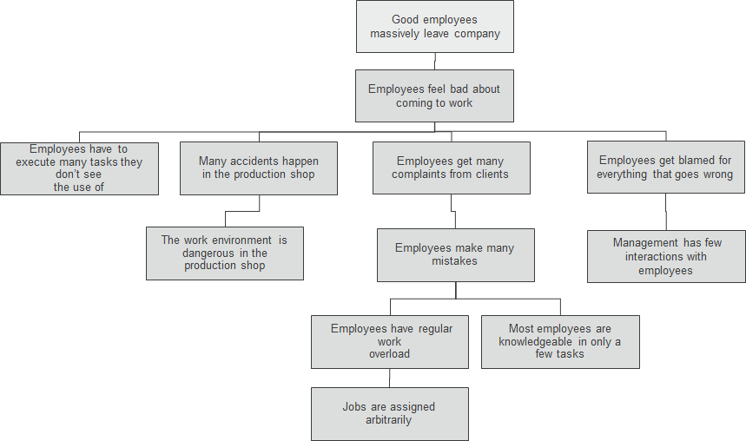

The following tips can help you make an adequate problem tree:

Step 1: Define the theme or topic
Before analysing a problem the participants have to agree about the topic to which the analysis will be applied. Make sure to verify in advance that everyone understands this topic in the same way. This topic sets the boundaries within which the analysis and discussion takes place. The 'topic’ which is selected must be something you know of for sure that it is actually something that is worrying the final target group.

So, it is important to check at the start of the workshop whether all stakeholders can accept this topic and agree about the meaning of the topic.

Step 2: Identification of stakeholders / parties

In the workshop an overview is again made of all parties involved which are related to the ‘topic’ in one way or another. If a new party is ‘discovered’ their opinion must also be involved in the analysis. If the party is crucial for the analysis a representative also has to be invited. In some cases the workshop will even be postponed.

Step 3: Indentify the real problems as perceived by every party

Every participant will be asked to brainstorm about problems related to the topic and write these down individually on cards.

In doing so the following principles have to be respected
- Clarity:
  - every problem is listed individually
  - no cause-effect relations in one problem description, i.e. not: “employees are stressed (effect) because they feel insecure (cause)”;
  - no combined problems, i.e. not: “employees do not feel inspired (problem 1) nor appreciated (problem 2)”
  - every problem is represented in short but complete sentences (including a verb) without abbreviations or jargon.
  - and also “a problem is always a problem for someone”. Not being able to determine whose problem it is means it is not a good description. So “little appreciation” becomes “employees are not very much appreciated by the management”. Otherwise it is also possible that e.g. the management finds that it is not much appreciated (other problem holder).
- Problems must be real:
  - it is very important not to present a ‘lack of solutions’ as a problem. This is not a representation of an actual negative situation as perceived by the (final) target group but the lack of a desired solution.

For example:
“employees are not adequately trained with regard to their tasks” does not really describe a problem but anticipates on the desired solution, i.e. that staff should be trained more adequately. The real problem is: “employees do not know well enough how to perform their tasks” The solution is not necessarily to give traditional training, but could also require better procedures or a simplification of the work.

A problem which implies that there is only one solution should always be avoided (unless there is really only one possible solution, e.g. “management does not give adequate instruction” is possible: something else, besides “management gives adequate instructions” is not a possible solution by definition. Because the Management is supposed to give adequate instructions).

Therefore, avoid the use of “lack of ...” in a problem description. This often leads to a ‘absent’ solution. It is better to describe how someone/a group is affected by a problem.

Persons trying to give a problem description but who are not really familiar with the problem situation will usually try to define problems as a ‘lack of solutions’. This is indeed ‘safer’ because those absent solutions are not yet available anyhow. This is inherent to ‘absent solutions’. There is a lot you can define that way without uttering untruths.

Problems, on the other hand, have to be really there and the ‘reporter’ can also be ‘punished’ if the said problems cannot be proven or demonstrated. The extent to which real problems are described in the proposal indicate to what extent writers are familiar with the problem situation of the parties involved. Therefore, this aspect is seen as an important criterion for the quality of the proposal which largely defines the ‘relevance’ of the project.

It is important not to increase certain solution-oriented actions during the problem analysis (e.g. management techniques). These belong in the work programme. If they are dealt with in the problem they are probably absent solutions. If these management techniques are introduced, but do not achieve their goal, the related problem can, of course, be described.

  - All parties involved in a problem have to acknowledge that it is a real problem. A problem tree can also contain a problem for a party other than the final target group (e.g. management is under pressure of customers" and therefore puts pressure on the employees) if this effectively acknowledged by both parties. It is important to link the quoted problem to the actors who are (may be) responsible for it. If this is not possible, the problem tree has not been adequately developed.

- Specifically: sometimes specific problems arise which only apply to certain subgroups. Without mentioning the subgroup, people could erroneously think that it applies to the entire group.

For instance,
Maybe only administrative staff loses lots of time with (a specific type of) regulations? If so, make sure to indicate this clearly in the problem tree! It will avoid getting problem trees which are so generic and vague that different groups do no longer recognise themselves in it.

If the problem analysis leads to the identification of subgroups which are not yet included in the description of the target group, this obviously requires updating. If no specific problems are listed for subgroups, please mention how these groups were surveyed about specific problems and what the answers of the target groups were. Mind, if it turns out that, in terms of problems, there are more differences than equalities between groups, it might be better to start up different projects, aimed at a more specific target group.

Taking into account the above principle the workshop leader will ask the participants to write down their problems on cards. It is recommended not to write more than 3 lines on each card to keep it legible. The workshop leader reads every card out loud and asks whether the content is clear to everyone. If the content is not clear, it must be clarified and adapted. The workshop leader then attaches the cards onto a board or other surface. All participants must be able to see the cards.

The description of the individual problems according to principles A, B and C is the input for assessment question 1.3.

Step 2: put the problems in a cause-effect relation

The group now looks for a problem to start the ‘tree’ with. A good starting problem is a problem where both causes and effects can be linked to and which is considered important by the final target group. We are looking for a problem which described a very painful reality among the target group.

- The workshop leader, together with the participants, decides what the cause-effect relation between the problems is. If the problem contributes to another problem, it must be positioned under the latter. If it involves a problem resulting from another problem, it should be positioned above it. If the problem is neither cause, nor effect, it should be positioned next to it (at the same height);
- The position of a problem in the cause-effect relation does not reflect the importance of a problem; anyway, at this stage we are unable to indicate the ‘major problem’ because every person involved has his or her own perception of what the most important problem is.
- The cause-effect logic must be elaborated both in depth and width (diversity of aspects). Causes must together offer an explanation which is as complete as possible of an effect and the effects of a problem (or the combination of problems) must also give an image which is as complete as possible.
- Confusion should be avoided between a cause-effect logic (causes precede effects in time: if A and B, then C ...) and a collection logic (A+B=C). Therefore, container concepts must be avoided to the greatest possible extent: e.g. “quality of labour” (=C). This concept can be divided in matters such as “employees hardly have any decision power"(=A), "employees are swamped with problems"(=B), etc.

When you have the feeling that the analysis presents a full image the reality, then it is time to stop. In that case, the cause-effect logic will in principle be well-elaborated both in depth (the roots of the problem are sufficiently probed) and in width (the diversity of the problems is understood). Obviously, you can always go back to the problem analysis to deepen or improve it when the time has come to develop the project design.

The problem tree as a whole is the input for assessment question 1.4

Step 3: further substantiating of problems

The problems have to be further substantiated, for example, by means of (existing) studies, a survey, project evaluations, exit interview of employees ... Please understand that a workshop to develop a problem tree does NOT in itself adequately substantiate this problem tree. The need to either or not substantiate the existence of certain problems will be felt in the course of the workshop but will obviously also require some effort after the workshop.

The substantiation is also input for assessment question 1.4.

Step 4: consider whether you should formulate several projects

If the problem analysis demonstrates that the problem area has more different than shared problems, it may be indicated to focus on more specific target group in different more specific projects.

To summarise: Problems have to be clearly described and real. Sufficient information must be given about specific problems of subgroups including gender and it must be specified how the existence (either or not) of these problems is verified with these specific groups and what the answers were. The cause-effect logic will be well-elaborated both in depth (the roots of the problem are sufficiently probed) and in width (the diversity of the problems is understood well enough). The majority of the problems is substantiated based on objective information (e.g. figures, evaluations, surveys, etc.). This is input for assessment criteria 1.3 and 1.4.

2.4 Describe your strategic choices on the basis of an objective tree.

The problem tree now becomes input for a further step: the formation of an objective tree (see figure). This involves converting negative situations into desirable situations.

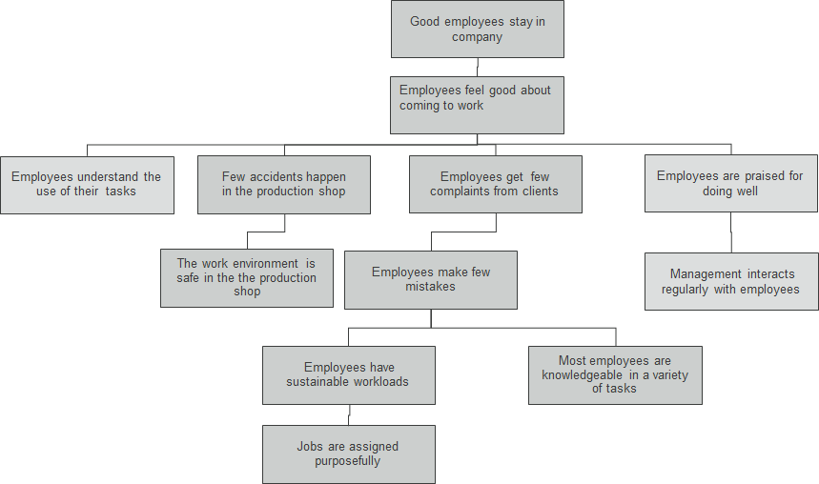

During the workshop all participants are asked to write an objective, problem by problem. These objectives are positioned on top of the problems they relate to. The following tips apply:

- Objectives are not activities.
    - Objectives are future, positive, desired situations.
        - An objective is a description of the future: what does the situation look like once it has been improved, reduced, developed, etc.
        - An objective is formulated as an achieved situation (in perfect tense), which you can look back upon when the project is finalised, e.g. “employees are happy to come to work”.
        - An objective is also always positive, so not “employees have less stress”, but “employees have an acceptable level of stress”;
    - Activities are represented by verbs like “improve ...”, “reduce ...”; “develop ...”, e.g. setting up an information campaign.
- Objectives are clear.
    - When it is difficult to convert a problem into an objective this may be due to the fact that it is too general or too vague. In that case, it is recommended that you first explain;
    - However, it is not necessary to be exact “in terms of quantities” at this stage. These details will be given based on the indicators once the objectives have been chosen. In an objective tree we do not yet need to see “100 employees spend maximum 10% of their time on applying administrative rules”.
- Objectives must be realistic.
    - They must be feasible within the timeframe;
    - There are problems for which it is not realistic to turn around the negative, existing situation. Two things can be done in this case:
        - Let the problem remain in the objective tree as a reminder that no actions can be taken but that the problem remains e.g. assignments arrive unexpectedly and unpredictably. Make sure, though, to explain why the problem cannot be solved;
        - Try to think of alternative objectives which can work around the problem, e.g. although you have no control over when customers need something, you can offer customers the opportunity to get a discount if they are willing to wait;

Complement the objective tree when formulating the objectives. It may turn out that some objectives are absent. In order to get a complete, coherent picture, additional objectives are formulated. However, it is not necessary to adjust the problem tree when formulating new objectives, though this is always an option.

The objective tree is a starting point, not an end point. Before the project objectives (global, specific and operation – see also logical framework in the next chapter) can be formulated, strategic choices first have to be made. Then, project objectives need to be formulated on the basis thereof. Therefore, it is not yet necessary to think about final project objectives at this point.

After forming the objective tree the last step in the analysis is made, i.e. making strategic choices. The tree below indicates that it is a choice not to work on the relations of employees with the management.

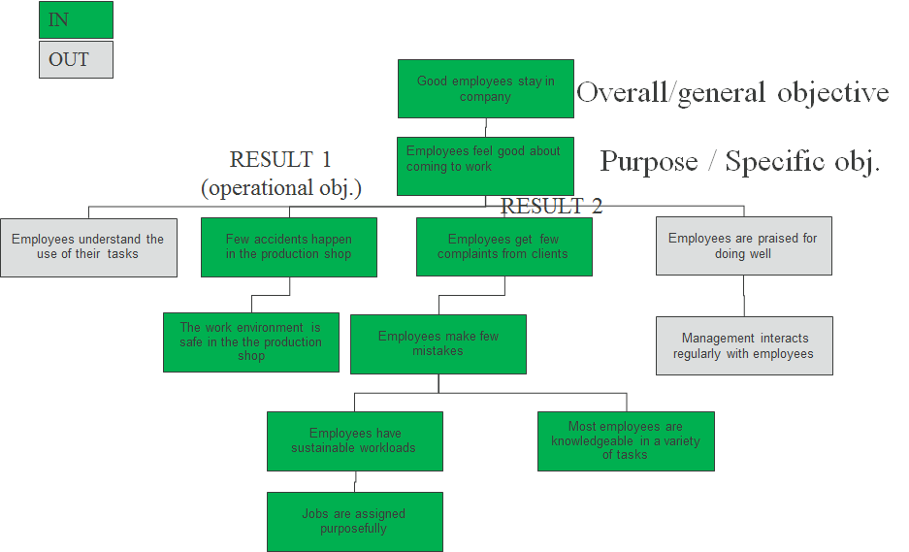

Below are some tips to make these choices consciously.

- The central objective of the project (specific objective / purpose) to be set out must reflect an intrinsic benefit (objective in itself) for the target group. It will indeed not be possible for the project to attain this objective without the cooperation of the final target group in the project. The target group must indeed be WILLING to use what the project will make available and therefore an intrinsic benefit must be accounted for.
- A means to check whether an objective from the objective tree either or not qualifies as a specific objective is to reformulate it and check whether the objective reflects a fundamental need of the target group. These needs are usually (more concrete) variants of one of the following (interrelated) categories:
- primary needs such as the need for food, health (including absence of unhealthy stress), etc.
- need of safety, stability, protection e.g. having a roof above your head, living in a safe neighbourhood, job, income and other securities, etc.
- the need to belong e.g. social relations with others (also at work), sense of community, etc.
- the need for appreciation e.g. respect from others, status, recognition, reputation, dominance, honour, feedback, etc.
- need for self-respect e.g. self-confidence, independence, freedom, excelling in something, etc.
- need for self-fulfilment (personal growth).
- Then, it must become clear what the relative importance of this type of aforementioned needs is in relation to each other. One way to make it clear quickly what the essence of the problem is, is to assign weights to the different objectives. This can be done in a workshop e.g. by asking to distribute a number of “votes” over the different objectives. This will, of course, reflect the vision of all stakeholders-participants in the workshop and not only that of the final target group. Neither does it provide the input the very which intrinsic objectives are given which weight. In addition it is still necessary to verify for (a selection of) the final target group which importance they attach to the different intrinsic objectives and to confront it with the vision of the other parties involved. If there is a divergence in terms of the most important problem, this must be explained. The opinion of the final target group will eventually be decisive. This will be the input for assessment question 1.3.
- All the objectives to which the selected specific objective contributes now become general/overall objectives. All objectives which contribute to the specific objective may be operational objectives / results. In the figure e.g. the choice is "employees are happy to come to work". This reflects a fundamental need (both having a job and finding fulfilment in the job). “Tasks are assigned while taking into account capacity", on the other hand, is not an objective in itself for employees. It does not reflect a fundamental need;
- Within the objective tree, different strategies can be found. A cluster of objectives, related to the specific objective, in indeed a potential strategy. In the example we see that one strategy is aimed at the relationship with the management. Look whether you have to choose between different strategies:
- If the specific objective is “employees are happy to come to work", then all underlying objectives should in principle be achieved. However, it is possible to choose to aim for one specific strategy. This choice is made on the basis of criteria like:
  - Are other initiatives ongoing in the field?
  - Available budget and other resources (including expertise, people, time, etc.)?
  - Available authorisation?
  - Which strategy contributes most to the achievement of the specific objective?
  - Which strategy is acceptable for the stakeholders, especially the final target group?
- In the example, you can opt not to include the strategy working on the relationship with the management in the project. However, in the future this issue must also be tackled or it will be impossible to achieve the specific objective. This means that either a parallel project needs to be launched, or another actor will be responsible for the implementation of this strategy.
- As previously said several objectives from the objective tree can be eligible to be selected as specific objective:
- “Employees feel good about coming to work” is not the only benefit which is considered intrinsically valuable by the target group. The same applies for customers who express their satisfaction (need of appreciation);
- What counts is the ambition level expected by the target group from the project: if the target group would already be very happy with customers expressing their satisfaction and not directly aimed its efforts to "feeling good", it is perfectly acceptable to include the first one as a specific objective (see figure below). “Feeling good” then becomes a part of the overall objectives of the project. Everything not covered by “satisfaction” automatically falls outside the scope of the project (does not even qualify as strategy);

- If a specific strategy is selected, you have to realize that if the objectives which were not selected, from which the specific objective depends, are not achieved, these are potential strategic risks (see figure below and also the chapter about assumptions under formulation) for the achievement of the specific objective. As indicated above, the specific objective cannot be reached without taking care of the risks.

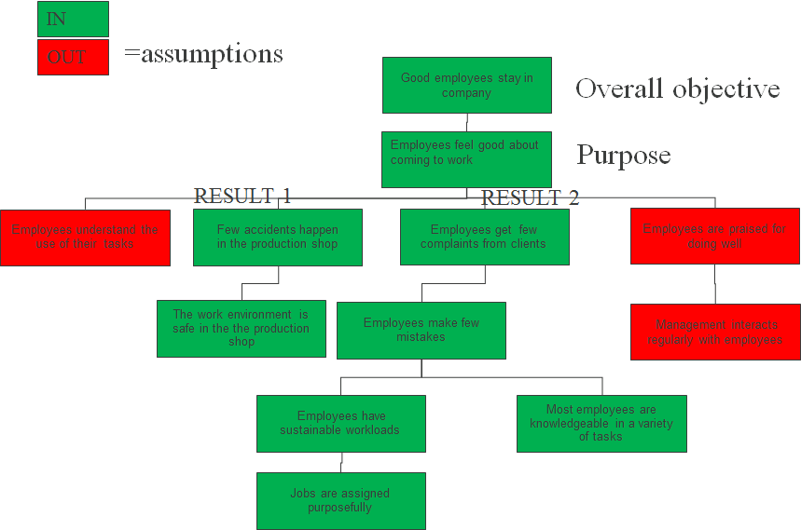

The end point of this analysis is therefore a first idea of the objectives for the project. The analysis forms a solid base for the formulation of the final project objectives as well as for the assumptions (see logical framework under "formulation").

To summarise: The relative importance of the problems which reflect an intrinsic need, from the perspective of the final target group, must be made clear. This takes place through the objective tree instead of directly in the problem tree. This is input for assessment criterion 1.3.

2.5. Situation of the project in the policy context
Promoters cannot come up with just any solution for just any target group. They have to be situated in the policy context described by the ESF call. So, it is not about situating the solution within the promoter’s or partners’ policy. Neither is it about the lessons/principles described in the call. It must also be made clear how to avoid that non-participants in the project experience negative effects.
This will be the input for assessment question 1.7.

3. Formulation

3.1 Logical framework

 | Formulation | Indicators | Sources | Assumptions
Overall objectives
(Long-term objectives to which the project indirectly contributes)
Specific objective
(benefit for the target group)
Operational objectives
(services, competences, practices, attitudes)
Main activities |  | in EUR | N/A

The logical framework is a template to be completed and consists of different rows and columns to be filled in.

The rows consist of the different types of objectives, except for the bottom row which names the project activities.

In terms of the rows with objectives, the columns have the following meaning:
The first column contains the formulation of the project objectives.
The second column specifies how these will be measured.
The third column specifies the measurement sources.
Finally, critical conditions about achieving the objectives are mentioned (the assumptions).

With regard to the activities, the first column must indicate the main activities (numbered on the basis of relevant operational objectives e.g. 1.2 means second main activity for the first operational objective) and in the second column the amount required for it.

All these aspects will be further explained below.

It is important to know that the logical framework is a summary of the project concept. Therefore, it is the basis of the project summary (instead of only a description of activities) which has to be filled in directly in the ESF application.

3.2 Explanation of objectives

A) Specific objective

A promoter must use the objective tree and strategic choice from the analysis phase (see figure below). It will point the way to the specific objective.

As mentioned when the strategic choice was discussed, the specific objective must:
- describe an intrinsic benefit for the target group;
- be derived from the problem analysis;
- be a priority for the target group.

The specific objectives from the problem/objective tree must now be formulated even better to make it really clear which sustainable benefit is in it for the final target group. “Employees feel good about coming to work” is a rather general statement and should become “employees are challenged by their job every day to further their career”. It is indeed not only about employees “feeling good”, but also about seeing an intrinsic benefit. The specific objective must become the slogan which moves the final target group to form part of the project.

If relevant differences (including with regard to gender) concerning the target group were cited in the description of the target group, you must check whether these must also be translated in the description of the benefit for the target group. The following questions have to be asked: to what extent is the nature and/or the impact of the benefits different between the subgroups?

A) Nature: e.g. acceptable work pressure is of a different nature among administrative staff than, for instance, for production workers. This is also shown in the indicators: e.g. administrative work pressure is measured by means of an “internal survey”, while for workers it is derived from the production speed.

B) Impact: e.g. the idea is to give employees more autonomy. Even though there will effectively be more autonomy for all subgroups, this will be more restricted for the administrative staff than, for instance, for staff dealing with external customers. This can already be visible in the objective tree if underlying objectives were described which are different for each sub-target group.

The more specific the nature of the benefit can be described, the more chance that it will effectively touch the right cord of the (sub-)target group to motivate them to contribute to the project. So, the idea is not to actually list different benefits as specific objectives (this could cause a problem with regard to cause-effect logics). But, the idea is to qualify one benefit in relation to the subgroups. A realistic understanding of the scope of the benefits for different subgroups is important in order not to disappoint certain groups later. It is also important to assign an adequate target figure to the indicators later.

If no differences are mentioned in the proposal, it should explicitly be mentioned how the representatives of the subgroups were surveyed in terms of this issue and what the answers were. This is useful anyway because it is not so evident and a direct survey usually quickly gives an adequate idea about the possible differences.

This will be the input for assessment question 1.5.

B) General objectives

Once the specific objective is defined, you can look in the objective tree which objectives are above the specific objective.

These are the general objectives the project will contribute to.

If the objective tree was adequately set up, the objective of the call can also be located somewhere in the tree. The objective of the call can coincide with the specific objective (but with a more restricted scope, e.g. not aimed at all employees in Flanders, but a part thereof) or will be located a bit higher up in the tree. If, however, the specific objective of the project is higher up in the objective tree than the objective of the call, the project would have a wider scope than the call, which is obviously not the idea. This could indeed result in activities which cannot be financed by the ESF.

C) Operational objectives

The operational objectives are actually the larger components which will be made available on the basis of the project to the final target group. These objectives can also be derived from the objectives contained under the specific objective in the objective tree. For each operational objective there is one problem and, related thereto, one objective in the objective tree.

However, these have to be converted into a description which makes it clear which new/changed knowledge, attitudes, practices and services will be available to the final target group.

ONLY the availability of the new/improved services, attitudes, knowledge and practices (e.g. behaviour of the target group, intermediaries or the ‘organisation’) are allowed as operational objectives.
In this respect, make sure not to confuse the activities of the project with the operational objectives.

For example: the training given by the project, is not the same as the knowledge resulting from it. It is the knowledge which can be used by the target group to attain a benefit, not the training.

Any absent solutions contained in the problem analysis may not be translated into operational objectives because this would imply including activities/milestones. If milestones are defined as objectives each project would a priori be 100% successful, except in case of bad management (implementing activities is also controlled by the project management).

A project can have as many operational objectives as you want, as long as these objectives can be controlled within one project. Usually the objectives just below the specific objective are chosen. However, you have to check whether these objectives make it sufficiently clear what the larger components of the project are.
It may be recommended to use a lower level of objectives if this makes the final aim clearer. All the objectives from the objective tree may indeed be new/changing knowledge, attitudes, practices and services. Remember to check, however, whether the specific objective is still entirely covered by the operational objectives.

These operational objectives have to be described specifically and concretely enough.
- Specifically: it is possible that there were problems which were ONLY applicable for a specific group (see problem analysis).
  - e.g. safety is only a problem for production workers in the problem tree
- Concretely: one competence, attitude, etc. is not the other
  - e.g. employees know how to perform their tasks: the tasks have to be clearly distinguished and must be converted in operational objectives
- This implementation can also be linked to a specific subgroup.
  - e.g. production workers perform other tasks than administrative staff.

Therefore, it is not enough to make a general operational objective e.g. “know how to perform tasks” for all employees!

Investigating whether concretization is required for the different subgroups mentioned in the description of the target group is mandatory! Information must be given about the different nature (or the way in which the existence or non-existence of different natures was tested) of the operational objectives for men and women (gender) and other relevant subgroups.

This is input for assessment question 1.6.

To summarise: The objectives have to be clearly formulated. The proposal describes a benefit for the final target group in the specific objective. This benefit is derived from the problem analysis if it is a problem which is considered a priority for the target group (based on the relative importance of the problems). Information is given about the different nature (or the way in which the existence or non-existence of different natures was tested) of the operational objectives and/or the ‘size’ of the benefit for men and women (gender) and other relevant subgroups. In terms of operational objectives, the need of delivering or improving specific services, competences, practices, attitudes, ... for the final target group (operational objectives) must be substantiated by an unambiguous relation with the problem analysis (for every objective there is maximum one problem from the problem tree). No activities/milestones are described for the operational objectives. Information is given about the different nature (or the way in which the existence or non-existence of different natures was tested) of the operational objectives for men and women (gender) and other relevant subgroups. The operational objectives are sufficiently explained in concrete terms. The above is input for assessment questions 1.5 and 1.6.

3.3 Substantiating the project logics from the logical framework

After formulating the actions the logical relation of the project objectives can be completely set out (see figure below).

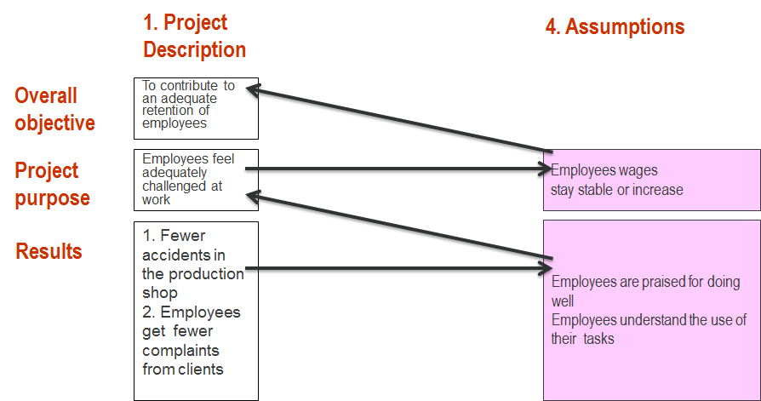

If the activities are implemented and the assumptions (see below) are fulfilled, the operational objectives are also achieved. If the operational objectives are achieved and the assumptions are fulfilled, the specific objective will be achieved. If the specific objective is achieved and the assumptions are fulfilled, the general objectives will be achieved.

With regard to the assumptions, please refer to the next chapter. The cohesion between the objectives must be substantiated as follows in the project proposal.

A) Relation specific objective and general objectives:

To what extent does a relation exist between the benefit for the target group (specific objective) and the long-term objectives (general objectives) of the project. You are required to use substantiating information (e.g. figures, evaluations, studies, comparisons with previous projects maybe from other regions or information obtained from the final target group and/or external experts).

B) information about the impact of the relation between the operational objectives and obtaining benefits

E.g. suppose new skills are developed, what is this going to achieve e.g. in terms of autonomy of employees (if this is the intended benefit)? To what extent can you measure and substantiate this? Are there studies, figures? What do experts, intermediaries and the final target group think?

In terms of B) you have to check whether this relation has an equal impact on all subgroups.

This is input for assessment question 2.4.

The cohesion between activities and operational objectives has already been detailed in the work programme.

Summary: The proposal contains objective information to substantiate a strong relation between benefit (specific objective) and long-term objectives (general objectives).
A strong relation is substantiated between all listed services, competences, practices, attitudes (operational objectives) and obtaining the benefit (specific objective) for the majority of the different subgroups.
This is input for assessment questions 2.3 and 2.4.

3.4 Assumptions

Risk identification may well be one of the most important components of good project design. It indicates how probable it is that a project will achieve its objectives, taking into account a number of crucial assumptions with regard to the external environment.
The distinction between internal and external is made as follows:
- internal is everything the promoter can, in principle, control,
- external are matters which can only be affected (in the best of cases).

Simultaneously, an assumption must also be probable. If it is improbable that an assumption will be fulfilled, it is not reasonable to assume it in the first place.
If it is sure that an assumption will be fulfilled, we do not have to worry about it.
Therefore, it must be doubtful but probable!

For example: if all project actions are implemented in the example process, there would be less accidents. However, if a very strong rise in orders were to take place, it could result in more accidents, regardless of the safer circumstances. It is doubtful but probable that the rise will be in line with the past and that a sudden strong rise is not going to happen.

The probability that the expectations about these external factors will come true must therefore be high enough. It must be substantiated. One way to substantiate this is by demonstrating that project activities were selected which try to increase the probability that the assumptions will be fulfilled.

For example: it is assumed that a, currently rather hesitant, management of a company will actively support a project about turning over the organisational structure throughout the implementation. However, the management is not a part of the project team and is can therefore not be controlled by the project. However, the project will provide some activities for the management which will probably make the management effectively support the project. The support of the management is therefore a reasonable assumption and may be included in the logical framework.

If these activities are not available, it is rather improbable that the management will effectively grant its support. In that case it would not be a reasonable assumption.

If it is a management which is plainly hostile against the project, it can be considered improbable that this will change quickly enough, even if the project management tries to influence their stance by means of project actions.

In both last cases it is a critical success factor: in that case the question is whether the project will succeed.

If project activities cannot make sure that the assumptions are more probable, the objectives will have to be reviewed (e.g. something the project was not going to address, is now included as an objective anyway) and redesign the project in a way that these assumptions are no longer relevant.

The scheme below provides a schematic representation of the above way of reasoning. In practice, only assumptions with a high importance and a high probability of truthfulness (though not 100% certain) may be included in the logical framework. However, it is not enough to use the scheme. As previously said the opinions about probability have to be substantiated (on the basis thereof it is concluded that it will probably come true).

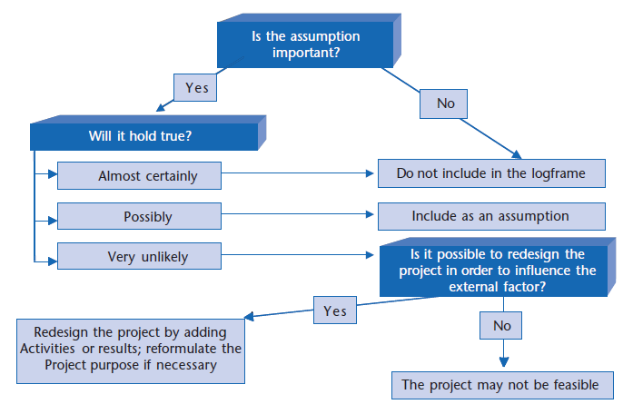

How can these ‘assumptions’ be identified?

If you have an objective tree at hand, you can already derive a whole range of possible assumptions: all the objectives the project is not going to do anything about (by choice or because they cannot be influenced) but which have to be achieve, if the specific objective needs to be achieved (see above under “analysis”) are a source of assumptions. Even if the project attains its operational objectives, it is not guaranteed that the specific objective will also be attained unless there are complementary actions which respond to those objectives and of which it is assumed that other actors, besides the project partners, will either or not implement them.

Other sources to fund assumptions include:
- Actions which can be taken by stakeholders which were not involved in the project (including sabotage);
- Changes in government policy;
- Trends in the external environment which are not expected to change in the course of the project;
- Etc.

Expectations with regard to actions of intermediary target groups (see also work programme) must also be included under assumptions!
- The actions of the intermediary target groups are external: not under the control of the project management, but affected by the project;
- These are important;
- Intermediaries will probably do what the project management hoped for. However, this has to be substantiated, like the other assumptions.

Assumptions at the lowest level of the logical framework (if actions were taken, what else must be assumed to achieve the operational objectives) can obviously only be finalised when the work programme is finalised.

To summarise: The most critical external assumptions are listed for different levels in the logical framework and it is substantiated for all these expectations that they will probably come true. This is input for assessment question 2.5.

3.5 Explain indicators and objectively verifiable sources

In order to explain what is actually meant by the objectives, we must generate indicators. “Measuring is knowing”! This is only about measuring objectives (specific and operational), NOT the activities. Activities are followed up by means of milestones (see “planning” below).

A good indicator is defined ‘SMART’, which means:
- With target figures (Specifically)
- Elements of the indicator (Measurable)
- Target group (who?)
- Quantity (can be counted). According to M/F?
- Quality (how good?)
- Time (when?)
- Place (where?)
- This also means that it must be clear how the information will be collected: where will the information come from? Who will collect it? Is it cost-efficient by making maximum use of existing sources (see figure). Collecting new information (e.g. by sending out questionnaires) is more complex and more expensive than using existing info (Acceptable)?

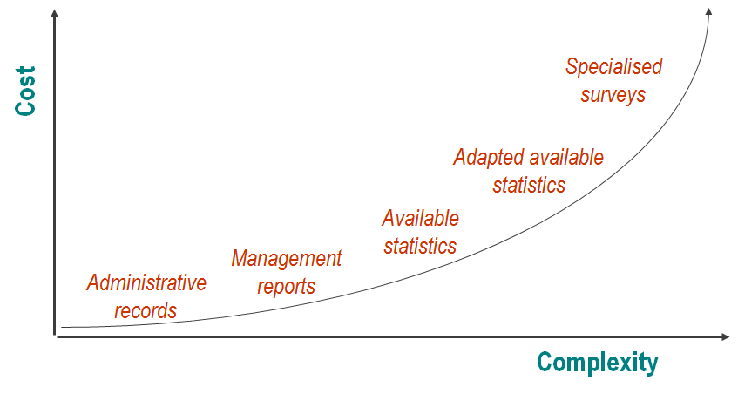
- It also needs to be determined when the information will be collected (On time)?
- The information must also be useful for the management (Relevant), which means that it is clear who will analyse the information, who will present the analysis, to whom and when?

A good example of an indicator is:

“5 women in the headquarters in Brussels have been promoted to a management position with at least 10 subordinates, by 2012”.

The data will, for example, be supplied by the HR manager: “The HR manager will ask the HR administration every six months, during the period 2011-2012, which of the project participants promoted and he will calculate how far the project is still removed from the target figure”.

In order to be useful a baseline (initial value at the time when the project proposal is written) must also be defined for each target value.

There are two kinds if indicators:

- Related to quantity: measures the quantity of something, e.g. in the above example “5 women in the headquarters in Brussels promoted to a management position with at least 10 subordinates, by 2012".
- Related to quality: measures human judgments, opinions, perceptions, attitudes, ... such as “satisfaction”, perception of “usefulness”, perceptions about the future, level of competence ... e.g. “80% of the women with a management position at the headquarters in Brussels are happy or very happy about their job by 2012 and less than 20% are unhappy or very unhappy (on a 5-point scale)”.

It is important to use a mixture of qualitative and quantitative aspects for each objective. Every method has advantages and disadvantages and only delivers a partial outlook on what you want to measure. Nevertheless, it is not recommended to use more than three indicators per objective.

To summarise: All indicators must be specific with regard to time horizon, quantity and quality (including target figures which clarify the progress compared to the current situation), as well as the target group (including the subdivision in man/woman components - gender) and place. It is clear for all indicators how the required information will be collected (sources). This is input for assessment question 3.1.

At this point, the Logical Framework is complete.
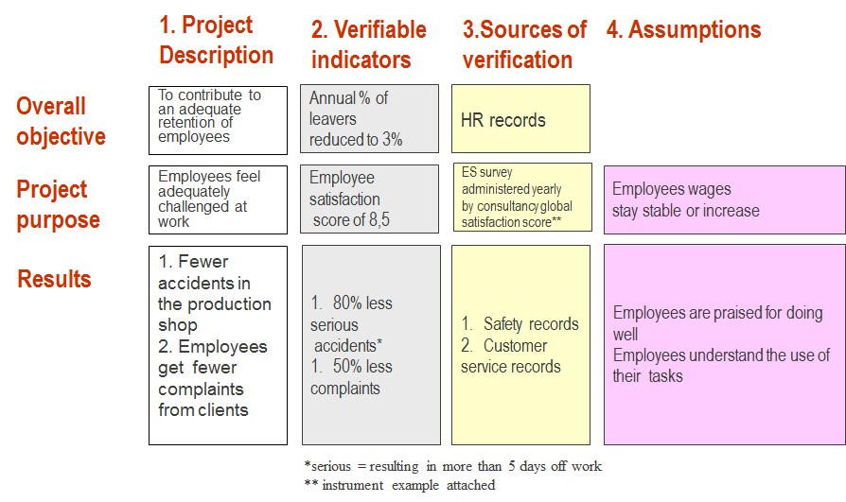
The next step is then to determine which activities will create the desired results.

3.6 Planning

A) Template: planning including activities which depend on each other and profiles of team members

A concise planning of the project must be prepared by means of the template provided by ESF (see below).

(Sub)activities |  |  | Phases/months
PHASE | Phase 1 | Start-up |  |  | Phase 2 | Roll-out |  |  |  | Phase 3 | Org/Profile  in project team |  | Aimed at
Year | 2007 |  |  |  | 2008
Month | Oct | Nov |  | Dec | Jan | Feb |  | Mar
1. Assertive attitude
1.1 Give assertiveness training |  |  |  |  |  |  |  |  |  |  |  |  | Final target group
1.1.1 Develop slides |  | A |  |  |  |  |  |  |  |  | Org 1/Trainer
1.1.2 Develop manual |  |  |  | B |  |  |  |  |  |  | etc.
1.1.3 Give training |  |  |  |  | C |  |  | D
1.2 Assertiveness coaching |  |  |  |  |  |  |  |  |  |  |  |  | Final target group
1.2.1 Develop coaching concept |  | E
1.2.2 Train coaches |  |  |  | F
1.2.3 Coaching sessions |  |  |  |  | G |  |  | H
Etc.

Explanation milestones | What can be tested?
A | Slides approved
B | Manual approved
C | 10 participants registered
D | 15 participants registered
E | Coaching manual written
F | 2 trained coaches
G | 5 coaching sessions
H | 10 coaching sessions

The following steps have to be followed when completing the template:

- Start with the operational objectives (project components) and number them
- Consider which main activities have to be carried out to achieve the operational objectives and number them according to the operational objective they contribute to (e.g. activity 3 of operational objective 1 becomes 1.3); activities (except for project management, communication and evaluation) are connected to only one operational objective; To make sure that activities will result in the achievement of the operational objective, an activity must be provided dealing with each of the underlying problems/objectives (see objective tree).
- Divide these main activities into subactivities (and also number them consequently) until reaching a level where a task package requires restricted interaction with other task packages and each task package can be assigned to one profile in an organisation.
- A profile consists of a concise description of the required competencies, experience and skills the performer of an activity needs. This profile can further break down this package after the start of the project, but this does not have to be indicated in the template.
- The project members (internal and external) should know, on the basis of the subactivities, what is expected from them. A middle course has to be found between tasks that are defined in too much detail (which may be demotivating for project staff) and formulating actions too generally which are difficult to follow up (through team meetings, etc.).
- Determine the time unit required to provide sufficient follow-up (at least monthly but can also be more frequent, for instance for short-term projects)
- Think of milestones for the subactivities which allow you to follow up the progress in time of the main activity they are part of. Explain these milestones. Milestones have to be measurable.
- Indicate when subactivities start / end by colouring the scheme.
- Indicate in the explanation which subactivities depend from each other (cannot start unless a previous activity has been completed).

This is input for assessment questions 3.1 and 3.2.

B) Working with intermediaries

- The project team sometimes has to influence an intermediary target group to improve the situation of the final target group. The problem/objective tree is a good starting point to check who you could work with in the project. For each objective in the objective tree you can consider which actors are involved. E.g. “Employee is sometimes confronted with too much work at the same time”: question is who is involved. The objective tree already reveals the role of the management and customers. But also the planning staff, the HR department etc. can be involved.

The template must indicate, at the level of the main activities, who is addressed by the activity of the project team: either the final target group or a specific intermediary.

In the above example (see A) of the partly completed planning template, the activities (training and coaching) are directly aimed at the final target group. The final target group will be trained and coached by members of the project team. The fact that coaches are also trained within the project in order to coach efficiently does not mean that they are an intermediary target group. Because the activity they are trained for (in the example , "coach the final target group") is also directly financed, this means that they are part of the project team and will be managed by the project manager.

It would be different if the “coaches” are for example direct superiors who are expected to coach their employees (the final target group) afterwards but where coaching as such is not part of the project plan. In that case, the question is whether the superiors will effectively coach. The project manager does not have control over this. In that case the changes in behaviour of the superiors are an effect, rather than a milestone. In that case the superiors are intermediary target group.

In the description of the activities it must be made clear which behavioural changes of any intermediaries towards the final target group are expected (e.g. more situation-oriented management).

This is input for assessment question 2.1.

C) Subgroups
Finally, it is important to take into account the different levels of attraction and possibility of participation to the activities for men and women (gender) and other relevant subgroups when developing activities.

Even if subgroups are taken into account in terms of issues and formulation of objectives, it is still possible that the actions in the project are not equally attractive or accessible for all members of the target group.

For example: to solve the problems with regard to contact between manager and employee, the suggestion is made to hold a consultation meeting every Wednesday. However, this excludes all women who are working four/fifths of a full employment in order to pick up their children from school on Wednesday afternoon.

Information must be given about the differences in attractiveness and possibility of participation (or the way in which the existence or non-existence of these differences was tested) of the operational objectives for men and women (gender) and other relevant subgroups. This is also input for assessment question 2.1.

This question is limited to activities which work directly with the final target group. This must not be answered if you work with intermediaries. This does not mean, however, that it may be useful to do so anyway! For intermediary target groups participating in an action can also be less attractive or possible.

To summarise: The planning contains enough milestones to measure the progress of the project at any time. The distribution of tasks is clear. It is supported on the basis of profiles connected to the different actors. All operational objectives are sufficiently guaranteed by activities and each (non-supported) activity is linked to maximum one operational objective. It is clear for the main project activities whether intermediary target groups will be defined and, if this is the case, which intermediaries are involved. The required changes in terms of behaviour of these intermediaries is described. Information is given about the differences in attractiveness and possibility of participation (or the way in which the existence or non-existence of these differences was tested) of the operational objectives for men and women (gender) and other relevant subgroups. Information is given about the differences in attractiveness and possibility of participation (or the way in which the existence or non-existence of these differences was tested) of the operational objectives for men and women (gender) and other relevant subgroups.
This is input for assessment questions 2.1, 3.1 and 3.2.

3.7 Lessons/principles
In order to make progress it is important for projects not to repeat mistakes made in the past and to use good practices.

It is important to make progress in the long term, making sure that projects do not to repeat mistakes made in the past and use good practices. These lessons may stem from existing research, project evaluations, etc. but in the first place also from the principles set out in the calls by the ESF Agency. Lessons which are not set out by the ESF must be substantiated with objective data (no opinions from a limited group of stakeholders but surveys among a representative group, studies, figures, etc.). ALL lessons from the ESF in the relevant sheets must explicitly be responded to. Project proposals may overrule the principles set out by the ESF Agency as long as it is substantiated with objective data. This substantiated objection is valid as a reference to the lesson set out by the ESF. If it is a theme about which the ESF does not have any lessons, this question does not apply. During the assessment the judges will verify whether none of the elements apply.

Project proposals must also concretely explain how lessons are put into practice. So it is not enough to mention the principle in general. An explicit link must be established with the activities in the work programme and it has to be made clear how these activities embody a certain principle.

To summarise: Any principles set out by the ESF will be mentioned in the proposal and will concretely be elaborated with regard to the actions of the project. This is input for assessment question 2.2.

3.8 Management

Good project management in the context of content-related assessment does not refer to financial management and audit. Please refer to the relevant guidelines for these aspects.

Coordination of persons (certainly if they come from different organisations) must be supported by means of a responsibility matrix based on the "RACI/VS” method. This means that activities are indicated on the left of a matrix. They can be defined both at a high level e.g. main activities, and on a more detailed level, depending on what is meaningful. The activities which require coordination across internal department borders or external organisation borders must be included as a minimum.

Persons are then assigned horizontally. They are usually connected to an organisational chart of the project or the organisation within which the project is implemented. This means that this scheme does not only have to be filled in for the promoter, but also for the partners.

The following roles are then assigned:
- “Responsible”: executes the work;
- “Accountable”: approves and holds final responsibility;
- “Supportive”: helps “R”;
- “Consulted”: two-way communication required between R and C to finalise the work;
- “Informed”: must be kept informed (one-way communication, e.g. R to A);
- “Verifies”: checks whether the work meets criteria and standards;
- “Signs”: decides whether the project is really finalised.

The template below must be completed in the project proposal.

Activity/Person | Project manager / promoter | HR Manager | External supplier
…

An example to explain the table:
Activity/Person | Project manager / promoter | HR Manager | External supplier
Activity: “Coaching line managers during the recruitment process” | Su: Supports line managers in their contact with external supplier | I: Is kept informed about the coaching process and the results attained with it | R: In charge of coaching the line managers
…

To summarise: RACI competences have to be defined in the project proposal for all relevant actors and activities. This is input for assessment question 3.2.

3.9 Evaluation
With regard to evaluation we refer to the specific guideline about this topic.

To summarise: by all means all components of an evaluation strategy have to be discussed and interrelated based on the evaluation guideline. External stakeholders, including the final target group, must be involved to provide information to judge about the project. It is also clear who is going to conduct the evaluation and who is going to follow it up and the time required for internals or a budget for externals is defined. This is input for assessment question 3.3.

4. How to organise an efficient and successful process to prepare my project proposal

Below you will find an example of how the process for a successful ESF project proposal could be organised. This process is not compulsory as such. Promoters are allowed to organise themselves differently, e.g. by making use of existing consultation structures.

Some promoters may have already completed an entire internal process and have already defined work programmes, objectives, etc. according to other logical processes than the ones defined by ESF. In this case it is recommended to complete an ESF-specific process by way of complementary exercise.

What | Who | How much time does it take? | Turnaround time
1. Formulate a first idea about the project: what is the (general) target group, what is the topic | Project team | 2 hours
2. Identify (representatives of) the final target group and ask them who the stakeholders are with regard to this problem | Project team | ½ day | 2 weeks
3. Organise an analysis workshop with relevant stakeholders | Project team | Preparation: 1 day | 3 weeks
3. Organise an analysis workshop with relevant stakeholders | Project team  Supporter  Stakeholder | Workshop: ½ day | 3 weeks
4. Process the results of the workshop, send to relevant stakeholders (including final target group) for feedback  Provide the necessary evidence (existing or new sources) | Project team | 1 ½ days | 2 weeks
 | Project team  (Internal / external) specialists, if any | 1 ½ days | 2 weeks
5. Fill in the objectives and assumptions in the logical framework | Project team | Preparation: 2 hours | 1 week
 | Project team  (Internal / external) specialists, if any | Workshop: ½ day + processing 1/2 day | 1 week
6. Feedback + adjustments | Project team | ½ day | 1 week
7. Define the indicators and sources as well as the main activities + lowest level assumptions | Project team | Preparation: ½ day | 1 week
 | Project team  (Internal / external) specialists, if any | Workshop: ½ day + processing 1/2 day | 1 week
8. Define the subactivities and timing | Project team (Internal / external) specialists, if any | ½ day | 1 week
9. Write the proposal in full | Project team | 1 day | 1 day
10. Feedback from stakeholders  + adjustments | Project team  Stakeholder | Workshop: ½ day | 1 week

A minimum turnaround time of three months should be taken into account, and a time dedication of 9 days. The above scheme presupposes that the promoter is already registered in the ESF application (with token or E-ID) and that the ESF quality label has been obtained. It also presupposes that the call and manuals have already been studied and that the decision to start the process has been made.

It is also an iterative process. Information from a later step may result in the fact that earlier steps have to be reviewed. The outcome-oriented calls remain outstanding (as long as resources are available), so promoters can take more time than specified above.

The outlined process creates room for 4 workshops. The agenda of these workshops can be established as follows:

Workshop | Agenda
1. analysis workshop | Initial discussion about the initial problem/theme 15-30 min.  Problem tree 45-60 min.  Objective tree 30-60 min.  Strategic choice 30-60 min.
2. objectives and assumptions | - Transfer objectives from the objective tree to project objectives and substantiating project logics 45-90 min.  - Assumptions (including substantiating probability) 30-60 min.  - Identify assumptions which need to be further investigated 30-45 min.  - Identify assumptions which can be removed by setting them as objectives or through actions 30-45 min.
3. the indicators, sources and main activities | - Go over objectives 15-30 min.  -Indicators 60-120 min.  - Sources 30-60 min.  -Main activities + lowest level assumptions 60-120 min.
4. feedback workshop | -Project objectives 60 min.  -Assumptions 60 min.  -Indicators/Sources 60 min.  -Activities 60 min.  Specific attention for: different attractiveness of and possibility of participation in activities for men and women (gender) and other relevant subgroups.

The participants to this workshop are different. The first and last workshops are aimed at the most relevant stakeholders (including final target group and potential intermediaries). The second and third workshops are more project-technical and therefore aim at the project executors and experts (internal and external).

There are also a lot of feedback moments which are important to submit a good project proposal. They mainly aim at the final target group (all subgroups) and the intermediary target groups:
- Step 4: do not forget to probe the relevant subgroups of the final target group about any specific problems for subgroups and to process the results thereof
- Step 6: do not forget the following matters:
  - To what extent would the benefits be different or stronger/less strong for different groups or for men versus women?
  - What about the nature of the operational objectives for men and women (gender) and other relevant subgroups?
  - Substantiating of project logics (relation SD-GD, OD-SD), for instance by surveying the final target group (insofar as not sufficiently substantiated in step 5 or as an additional test)

5. Reporting

5.1 Interim

In interim reports promoters must, based on the original project planning, report whether they are on schedule both in terms of timing and content of the actions. If this is not the case the causes of the deviations must be explained and a new plan must be presented with a detailed overview of the changes.

It must also be explained to what extent the objectives and indicators of the project have to be either or not adjusted. This may be because of the aforementioned deviations in the implementation, but also because some assumptions are not fulfilled (e.g. no economic crisis was expected but it turned out differently) or because (based on evaluations) you have learned that the project logics as designed in the logical framework is not elaborated enough (e.g. the problems on which the objectives were finally grafted may not have been understood well enough at the time when the proposal was written). Changes in the logics of the project can also have been a cause to change the project plan (e.g. remove some activities and implement others).

Finally, a report about the progress of the evaluation activity is also required, as well as any conclusions which can be drawn. The latter can also be the substantiation of the aforementioned deviations of the original proposal.

5.2 Final
In the final report you must, following the status of the interim report, again explain the progress with regard to the planning. This time no revised planning must be submitted, but you have to discuss what was and what was not accomplished (on time) and why.

The final achievements in terms of objectives and indicators also has to be set out and deviations of the status in interim reports must be explained. In this case unfulfilled assumptions may also be the cause of deviations.

Finally, also the final evaluation report must be submitted.

ANNEX

A. application form questions

To submit a project some general questions have to be answered directly in the ESF application. A document with content-related questions has to be uploaded in the ESF application as an attachment (see below). Finally, a spreadsheet has to be filled about cost and financing aspects.

Questions in the document to be uploaded are:

1. Analysis

  - Describe the most relevant features of the final target group (including gender aspects) and their relevance for the project. Mention the relevant subgroups.

  - Describe the stipulations with regard to involving intermediaries, as well as the final target group in the project formulation/execution. Also specify which persons and/or positions (roles/jobs) from which organisations are involved.

  - Describe the problems of the final target group on the basis of a problem tree.

- Problem tree
- Substantiating the problems
- How the specific problems for subgroups where probed and relevant results

  - Describe your strategic choices on the basis of an objective tree.

- Visualisation of the objective tree while indicating the specific objective and operational objectives
- Discuss the importance of the objectives in the objective tree which reflect an intrinsic need

1.5 Situation of the project in the policy context outlined in the call document (including mention of how it is made sure that non-participants will not suffer any negative effects.

2. Formulation

  - Logical framework complete the template below
 | Formulation | Indicators | Sources | Assumptions
Overall objectives
(Long-term objectives to which the project indirectly contributes)
Specific objective
(benefit for the target group)
Operational objectives
(services, competences, practices, attitudes)
Main activities |  | EUR | N/A

  - Explanation of the objectives

a) Specific objective: explain the objective, including the indicators. To what extent does the specific objective differ in terms of nature and size from the same benefit for different subgroups. If there are no differences, how was this probed among the sub-target groups and what were the answers?
b) Operational objectives: explain the objectives, including the indicators. If the operational objectives were not further specified in terms of subgroups of the target group, how were these subgroups probed and what were the answers?

2.3 Substantiating the project logics

- Relation specific objective and general objectives
- Relation operational objectives and specific objective:
  - Impact of the relation between use of the operational objectives and obtaining the benefit (specific objective)
  - Information about differences between subgroups

  - Explanation of assumptions: substantiating that the expectations will probably be fulfilled

  - Explanation about indicators and sources

  - Planning :

- Complete the template below and describe the milestones

(Sub)activities |  |  | phases/months
PHASE | Phase 1 | Start-up |  |  | Phase 2 | Roll-out |  |  |  | Phase 3 | Org/Profile  in project team |  | Aimed at
Year | 2007 |  |  |  | 2008
Month | Oct | Nov |  | Dec | Jan | Feb |  | Mar
1. OD 1
1.1 |  |  |  |  |  |  |  |  |  |  |  |  | Final target group
1.1.1 |  | A |  |  |  |  |  |  |  |  | Org 1/Trainer
1.1.2 |  |  |  | B |  |  |  |  |  |  | etc.
1.1.3 … |  |  |  |  | C |  |  | D
1.2 |  |  |  |  |  |  |  |  |  |  |  |  | Etc.
1.2.1… |  | E

Explanation milestones:
A=
B=
Etc.
- Explanation of activities: which activities depend from each other (which activities have to be completed before another can start)?
- Explanation of expected behavioural changes of intermediary target groups per main activity:
- Explanation of project executor profiles:

2.7 Lessons/principles: explain for each lesson (from the ESF sheets applicable to your project) which main activities embody this lesson and how. It must be clear every time which lesson from the sheets is discussed.

2.8 Management: complete the RACI template below for activities which require coordination across internal department borders and organisational borders.

Activity/Person | Person 1 | Person 2 | …
Activity 1
Activity 2
…

2.9 Evaluation: describe how the project will be evaluated

- Purpose of the evaluation:

- Time of the evaluation:

- Type of evaluation:

- Evaluation questions:

- Reason of the evaluation:

- Evaluation steering group:

- External or internal evaluators:

- Internal time occupation / external budget:
B. reporting form questions

- Logical framework: complete the template below and explain changes (nature, reason and consequences) as compared to the original project proposal/the last report.

 | Formulation | Indicators | Sources | Assumptions
Overall objectives
(Long-term objectives to which the project indirectly contributes)
Specific objective
(benefit for the target group)
Operational objectives
(services, competences, practices, attitudes)
Main activities |  | EUR | N/A

Explanation of changes:

- Planning :

a) complete the template below and explain changes (nature, reason and consequences) as compared to the original project proposal/the last report.

(Sub)activities |  |  | phases/months
PHASE | Phase 1 | start-up |  |  | Phase 2 | Roll-out |  |  |  | Phase 3 | Org/Profile  in project team |  | Aimed at
Year | 2007 |  |  |  | 2008
Month | Oct | Nov |  | Dec | Jan | Feb |  | Mar
1. OD 1
1.1 |  |  |  |  |  |  |  |  |  |  |  |  | Final target group
1.1.1 |  | A |  |  |  |  |  |  |  |  | Org 1/Trainer
1.1.2 |  |  |  | B |  |  |  |  |  |  | etc.
1.1.3 … |  |  |  |  | C |  |  | D
1.2 |  |  |  |  |  |  |  |  |  |  |  |  | Etc.
1.2.1… |  | E

Explanation of changes in milestones:
A=
B=
Etc.

b) Explanation of changes in activities:
c) Explanation of (expected) behavioural changes of intermediary target groups per main activity:
d) Explanation of change of profiles of project executors:

- Describe the progress of the evaluation works and explain any conclusions. Enclose the evaluation report (only for final report).

C. Testing the quality of ESF project proposals

Practical guidelines:

Standardised schemes are used to assess the quality of project proposals.

Three criteria are assessed:
- Relevance
- Feasibility
- Good project management

The assessor must give an explanation for all scales.

Only the scores below can be given. It is not possible to use half points. You always have to start at the top of the scale. If the description at the highest level is not FULLY met, you have to go down to the level where full correspondence is reached.

The following example may clarify the above:
4 | The cause-effect logic will be well-elaborated both in depth (the roots of the problem are sufficiently probed) and in width (the diversity of the problems is understood well enough).  The majority of the problems is substantiated based on objective information (e.g. figures, evaluations, surveys, etc.).
3 | The cause-effect logic will be well-elaborated both in depth (the roots of the problem are sufficiently probed) and in width (the diversity of the problems is understood well enough).  A limited number of problems is substantiated on the basis of objective information (e.g. figures, evaluations, surveys, etc.) rather than the opinion of a limited number of stakeholders.
2 | The cause-effect logic is poorly-elaborated either in depth (the roots of the problem are sufficiently probed) or in width (the diversity of the problems is understood well enough), but is NOT weak for both aspects simultaneously.  A limited number of problems is substantiated on the basis of objective information (e.g. figures, evaluations, surveys, etc.) rather than the opinion of a limited number of stakeholders.
1 | The cause-effect logic is poorly-elaborated both in depth (the roots of the problem are sufficiently probed) and in width (the diversity of the problems is understood).
0 | The cause-effect logic is not followed, instead a logic of association is used (e.g. mind maps).

If, for instance, most of the problems are substantiated, but the cause-effect logics are only elaborated in depth, no 4 can be scored. Because level 3 also requires the cause-effect logic to be fully elaborated, the next level which applies is score 2. If, on the other hand, a limited number of problems is substantiated, but the cause-effect logics is fully elaborated, a score 3 may still be attained. This reflects the idea that a well-elaborated cause-effect logics is more essential for an approval of the proposal than its substantiation. Simultaneously, it also reflects that it is more difficult for promoters to substantiate the problems than to properly elaborate on the cause-effect logics. Therefore, expectations may be higher with regard to the latter aspect.

Principles:

For “outcome”-oriented calls the principle of the assessment is that the success for the final target group of a project can largely be explained by the quality of the process which was followed when formulating the project. The criteria below therefore mainly test the quality of the writing process based on the output of this process included in the file.

This also ensures that priority is given to original projects which would not (as such) take place if no subsidies were to be granted. Going through the process concerned indeed leads to the fact that at least substantial changes are made to the benefit of the target groups concerned in the existing project ideas or, in the most favourable situation, that they can be fully implemented based on the ESF call.

The principle of the assessment is also maximum transparency and predictability for promoters. That is why standardised assessment scales are used. Predictability is indeed only possible if all judges strictly adhere to these criteria. However, within the criteria there is room for interpretation e.g. in the above example the assessment takes place on the basis of:

“The cause-effect logics is well elaborated both –n depth (causes together form an explanation which is as complete as possible of effects) and in width (diversity of the problems). The majority of the problems is substantiated based on objective information (e.g. figures, evaluations, surveys, etc.)”.

However, what is “well” and what is “the majority”? This room for interpretation is unavoidable and is the reason why we work with three independent judges. In principle a promoter should be able to give a score to his own file and this score should be quite similar to the scores of the judges.

Finally, the importance attached, among others by Europe, to man-woman relations (gender), as well as specific problems for specific target groups (e.g. migrants, the elderly, etc.) is reflected in six of the assessment questions where it is not possible to score a 4 (highest level), but maximum a 3, unless it is explicitly taken into account.

1. Relevance
A project is designed and implemented to solve issues for the final target group. The relevance of the project is the extent to which real problems will be tackled. This depends on the answers to the following questions.

1. Is the target group adequately described?

a) A clear description of the final target group must at least describe the social-economic roles/positions (training level/competencies, health, income, age class, ethnic origin, geographic location, ...) relevant for the project. Other features which may be relevant depending on the project should also be described (e.g. nature and level of discrimination, features of the jobs to be performed, family relations, etc.).

b) Information must also be provided about gender aspects (respective roles/positions of men and women).

c) All this information is only useful if the relevance with regard to the project is demonstrated, e.g. to explain that the final target group has subgroups with differences which need to be taken into account for the project setup. Therefore, it is not enough to list these features in general. The features have to be described in the context of the project. It must, for example, be clear whether or not there are subgroups of the final target group (e.g. lower skilled employees vs higher skilled employees).

Based on component a), 2 is the maximum that can be reached. To score a 3 the component c) also has to be included. The highest level is reached if b) is also elaborated.

4 | The description contains the most relevant features, including gender aspects and these are largely elaborated with regard to relevance towards the project. This will also make clear which subgroups there are.
3 | The description contains the most relevant features and these are largely elaborated with regard to relevance towards the project.
2 | The description contains the most relevant features.
1 | A limited number of features is mentioned.
0 | There is no description.

2. Will there be sufficient ownership of the project?
Ownership of the project by both the final target group (including via representatives of the final target group/end user) and the intermediaries which may be directly addressed by the project is crucial both in terms of relevance and feasibility of the project during and after the implementation (sustainability). “Empowerment” refers to the extent to which the target group feels involved in the project design and implementation. “Partnership”, on the other hand, refers to the extent in which relevant intermediaries are involved in the project.

a) Two levels of participation are used: formal decision authority and consultation.

In the first case the parties can block a project, in the second case their remarks must be taken into account to the largest possible extent but they cannot formally block the project. This means that if a rejected project proposal is submitted by the promoter, there was de facto only consultation. The exact stipulations of how this is organised must be clear.

b) Also the participation will be considered, both for the design and the implementation of the project. It always concerns the entire project (proposal). It is not enough if the final target group has only been requested to provide input for e.g. a problem tree or a certain part of the implementation of the project. Of course, not all members of the intermediary or the final target group/end user have to be involved; representatives should suffice.

In the scale below the two aspects above are probed. Only if both parties are able to co-decide both about the implementation and the design, the highest score can be obtained. In any case, the specific stipulations and the specific representatives have to be explicitly mentioned. If this is not the case, the maximum score is 0.

4 | The specified (representatives of) relevant intermediaries and the final target group have been able to formally approve or reject the project proposal (will only be submitted if approved). During the project implementation these parties will regularly be consulted and their feedback will be taken into account. They can formally block the project if this does not happen. The stipulations are explicitly stated for both groups.
3 | The specified (representatives of) relevant intermediaries and the final target group have been able to formally approve or reject the project proposal (will only be submitted if approved). During the project implementation these parties will regularly be consulted and their feedback will be taken into account. However, they are unable to formally block the project. The stipulations are explicitly stated for both groups.
2 | The specified (representatives of) relevant intermediaries and the final target group have been able to formally approve or reject the project proposal (will only be submitted if approved). The stipulations are explicitly stated for both groups.
1 | The specified (representatives of) relevant intermediaries and the final target group will be consulted about the entire project proposal. The stipulations are explicitly stated for both groups.
0 | The promoter alone decides about the project proposal and implementation. The representatives of the final target group and the relevant intermediaries are not even consulted with regard to the entire project proposal or it is not clear whether this has happened or not.

3. Have the problems been clearly described and real?

a) Problems are clear descriptions of real negative situations in a specific part of society/organisations. Project proposals are usually limited to issues experienced by intermediary organisations/service providers in the implementation of their tasks (existing solutions). However, these existing solutions may be not or only partly relevant to the problems of the final target group. Therefore problems may not be formulated as “absent solutions" (activities). It must be about problems which are acknowledged to be real by all parties involved. It is therefore possible that a problem is named which is not a problem as such for the final target group (e.g. manager has a lot of stress) but which affects a problem for the target group in a cause-effect relation (e.g. manager is aggressive towards employees).

b) The relative importance of the problems which reflect an intrinsic need, from the perspective of the final target group, must be made clear.

c) Problems also have to be formulated specifically enough instead of vague, generic, general. A problem analysis becomes specific when it is acknowledged that different subgroups (for instance with regard to gender) can be faced with different (variants of) problems within the target group. Therefore, shared but also specific problems must be mentioned. If no specific problems are listed for subgroups, please mention how these groups were surveyed about specific problems and what the answers of the target groups were.

Based on the first aspect, 2 is the maximum score that can be reached. To score a 3 the second aspect also has to be included. The score a 4, the third one also.

4 | The majority of the problems is clearly described and is real (no or little lacking solutions).  The relative importance of the problems which reflect an intrinsic need (through the objective tree), from the perspective of the final target group, must be made clear.  For the majority of problems sufficient information is given about specific problems (the way in which these were probed) of subgroups, including gender.
3 | The majority of the problems is clearly described and is real (no or little absent solutions).  The relative importance of the problems which reflect an intrinsic need (through the objective tree), from the perspective of the final target group, must be made clear.
2 | The majority of the problems is clearly described and is real (no or little absent solutions).
1 | A limited number of problems is clearly described and real (too many absent solutions).
0 | No problems are described.

4. Is the problem analysis of good quality?

a) Such a problem analysis does not only describe problems (see above) but also tells us why problems (continue to) exist. To this end a systematic analysis is required in which the interrelation of problems of a different nature is explained (cause-effect) instead of just randomly stating the problems. There should be no “gaps” in the analysis. The cause-effect logic must be well-elaborated both in depth (the roots of the problem are sufficiently probed) and in width (the diversity of the problems is understood). Adequate elaboration on cause-effect relations is indispensable to formulate the objectives of the project.

b) Problems must also be substantiated, meaning that they cannot be merely based on a personal opinion but have to be based on objective information (e.g. figures, evaluations, surveys, etc.). If this information is not available to the promoter, it must be collected to write the project proposal. Without this objectivation the project may be based on completely inadequate foundations. A workshop in which a number of representatives of stakeholders build a problem tree is not enough in itself. It is exactly that problem tree which is further tested with regard to reality.

In the scale below the two aspects above are probed. To rise and reach the highest score both aspects have to be taken into account.

4 | The cause-effect logic will be well-elaborated both in depth (the roots of the problem are sufficiently probed) and in width (the diversity of the problems is understood well enough).  The majority of the problems is substantiated based on objective information (e.g. figures, evaluations, surveys, etc.).
3 | The cause-effect logic will be well-elaborated both in depth (the roots of the problem are sufficiently probed) and in width (the diversity of the problems is understood well enough).  The majority of the problems is substantiated based on objective information (e.g. figures, evaluations, surveys, etc.).
2 | The cause-effect logic is poorly-elaborated either in depth (the roots of the problem are insufficiently probed) or in width (the diversity of the problems is understood well enough), but is NOT weak for both aspects simultaneously.  A limited number of problems is substantiated on the basis of objective information (e.g. figures, evaluations, surveys, etc.) rather than the opinion of a limited number of stakeholders.
1 | The cause-effect logic is poorly-elaborated both in depth (the roots of the problem are insufficiently probed) and in width (the diversity of the problems is not understood well enough).
0 | The cause-effect logic is not followed, instead a logic of association is used (e.g. mind maps).

5. Does the project make it clear which benefit (specific objective) will be obtained by the final target group on the basis of the project?

a) A benefit is obtained if the status of the target group improves as compared to their unfavourable starting position. A benefit which has been obtained must meet the real and intrinsic need of the final target group. These benefits are acquired based on the use of the services, competences, practices, attitudes ... made available by the project. The benefit may not described these services, etc, NOR their use. The specific objective must involve an objective which is intrinsically valuable and motivates the target group (e.g. increased self-confidence, a better job, better health), NOT about something which is only a means (e.g. competences, etc.). It must also be derived from the problems/objective tree when it is a specific problem/objective which is set as a priority for the target group (relatively more weight as compared to other problems/objectives). The relative importance of the problems in relation to each other, from the perspective of the final target group, must be made clear. There may only be one specific objective which indicates one intrinsic need.

b) If relevant differences (including gender) about the target group are cited (through the description of the target group and/or the analysis of the problems grafted on it), these differences must also be translated in the description of the benefit for the target group (specific objective): to what extent is the size and/or the nature of the benefits different between the subgroups? If no differences are mentioned, it should explicitly be mentioned how the subgroups were surveyed in terms of this issue and what the answers were.

In the scale below levels 0-3 refer to the first aspect above. To reach the highest scale, however, the second aspect also needs to be taken into account.

4 | The proposal describes one benefit for the final target group in maximum one specific objective. This benefit is derived from the problem analysis if it is a problem which is considered a priority for the target group (based on the relative importance of the problems).  Information is given about the different nature (or the way in which the existence or non-existence of different natures was tested) of the operational objectives and/or the ‘size’ of the benefit for men and women (gender) and other relevant subgroups.
3 | The proposal describes one benefit for the final target group in maximum one specific objective. This benefit is derived from the problem analysis if it is a problem which is considered a priority for the target group (based on the relative importance of the problems).
2 | The proposal describes the use of the services, etc. rather than a benefit in the specific objective.
1 | The proposal describes services, competencies etc. rather than a benefit in the specific objective.
0 | The proposal describes activities/milestones rather than a benefit in the specific objective.

6. Is the request for services, competencies, etc. (operational objectives) confirmed by the problem analysis?

The proposal must describe what the final target group will actually be able to use, i.e. “services, competencies, practices, attitudes ...” (operational services) to obtain a benefit (specific objective) rather than project activities which lead to the fact that services, competencies, practices, attitudes ... (operational objectives) become available to specific (sub)groups (including gender).

a) The need for the final target group to deliver or improve these services, competencies, practices, attitudes (reflected in the operational objectives) is substantiated on the basis of a clear relation with the problem analysis (see the objective tree) insofar as it was adequate (see quality of the problem analysis and the description of the problems of the final target group). For each operational objective there is one problem (and, related thereto, one objective in the objective tree). Any absent solutions contained in the problem analysis may not be translated into operational objectives because this would imply including activities/milestones. An example: jobseekers do not use training to find a job, but they use the competencies they have acquired on the basis of the project activity “training”. “Lack of training” is a absent solution while the real problems is rather ‘jobseekers’ skills do not match employers’ expectations”. Delivering “training” is a milestone and completely within the promoter’s control. “Skills” refer to effects which can only be influenced. If milestones are set as objectives, every project would, except in case of bad management, be 100% successful.

b) The operational objectives also have to be concrete. No two competencies are the same. For each competence a different operational objective must be set.

c) The operational objectives must be specific: it must be clear which (sub)group an operational objective refers to. If the nature of the objective is different depending on the specific relevant subgroup within the target group, this must be taken into account. Information must at least be given about the different nature (or the way in which the existence or non-existence of different natures was tested) of the operational objectives for men and women (gender) and other relevant subgroups.

In the scale below levels 0-2 refer to the first aspect above. In order to reach level 3 the second aspect has to be taken into account. To reach the highest scale, the third aspect also needs to be taken into account. If no relevant differences are revealed in the description of the target group nor a need to concretise, level 4 and 3 will automatically be put on a par. A relation with a solid problem analysis is also required. If the problem analysis were not solid, the judge will neglect this part of the criterion.

This criterion does not assess whether the operational objectives adequately cover the problems in order to actually achieve the specific objective. This is assessed under feasibility.

4 | In terms of operational objectives, the need of delivering or improving specific services, competences, practices, attitudes, ... for the final target group (operational objectives) must be substantiated by an unambiguous relation with the problem analysis (for every objective there is maximum one problem from the problem tree). No activities/milestones are described for the operational objectives. Information is given about the different nature (or the way in which the existence or non-existence of different natures was tested) of the operational objectives for men and women (gender) and other relevant subgroups. The operational objectives are sufficiently explained in concrete terms.
3 | The need of delivering or improving specific services, competences, practices, attitudes, ... for the final target group (operational objectives) must be substantiated by an unambiguous relation with the problem analysis (for every objective there is maximum one problem from the problem tree). In the majority of cases no activities/milestones are described for the operational objectives.
2 | The need of delivering or improving specific services, competences, practices, attitudes, ... for the final target group (operational objectives) must be substantiated for the majority of the objectives by an unambiguous relation with the problem analysis (for every objective there is maximum one problem from the problem tree). In the majority of cases no activities/milestones are described for the operational objectives.
1 | The need of delivering or improving specific services, competences, practices, attitudes ... (operational objectives) is only substantiated in general by the problem analysis (no unambiguous relation between one objective and one problem). In the majority of cases no activities/milestones are described for the operational objectives.
0 | For the majority activities/milestones (which can be implemented through the actions of the project) are described in the operational objectives instead of effects (which can only be influenced by actions)

7. Does the project proposal explain how the project is situated in the policy context outlined by the call?

Promoters cannot come up with just any solution for just any target group. Solutions have to fit into the policy context described by the ESF call. Projects endorsing several policy lines simultaneously will therefore be more relevant. However, it is not enough to just state this. Evidence has to be provided by concrete reference to elements in the project proposal which clarify the relation. It also has to be made clear how any negative effects for non-participants can be avoided. These and other elements may be considered in the scoring below.

Because of the importance of a solid policy orientation double scores apply to this question.

8 | The project is extremely relevant for the policy.
6 | The project is relevant for the policy.
4 | The project is moderately relevant for the policy.
2 | The project is little relevant for the policy.
0 | There is no information.

GENERAL ASSESSMENT AND RELEVANCE:
MAX score = 8*4=32. Min. 60% of this maximum score must be obtained. If the resources are insufficient the % is raised to 70%.

2. Feasibility
Can the idea be implemented in a sustainable manner? The following is taken into account: logical consistency, are the specific features of (subgroups of) the final target group and their local context considered and are the risks acceptable. It is also considered whether principles / lessons which apply to the project proposal are effectively included.

1. Will the project activities lead to obtaining the operational objectives?

a) Most projects do not only work directly together with the final target group but also with intermediary target groups. Which intermediary target groups are important could be derived from the problem analysis, also making clear which actors are involved in which problems. It is important to have a good idea bout which changes in terms of behaviour of the intermediaries to the final target group is hoped for (e.g. managers who become more flexible towards employees who have care tasks towards children).

For each activity in the work programme it must be clear whether an intermediary target group is involved or directly the final target group. If an intermediary target group is used, you have to describe what is expected from them as a reaction to the project activities. Without the cooperation of intermediaries, the project actions will have little effect on the final target group.

b) The activities have to be clearly related to one of the operational objectives of the project and one and the same activity may NOT be related to different objectives unless it involves supportive actions (e.g. evaluation, project management, etc.). All operational objectives also have to ne sufficiently guaranteed by project activities. The one-on-one relation between activities and objectives is guaranteed if the objectives are taken as a point of departure for an in-depth reflection on the best project approach to achieve EVERY operational objective and NOT trying to connect and existing work programme to these objectives. In the last case there is a big chance that the objective will not be reached because the activities are not designed target-oriented right from the start.

c) Finally, you also have to consider whether the activities are just as attractive for the relevant subgroups (including men and women) and whether there is equal opportunity of participation. To this end, information must be collected from these groups.

Based on the first component above, 2 is the maximum score that can be reached. To score higher, the second component also needs to be considered. In order to reach the highest level the third component also needs to be ok.

4 | All operational objectives are sufficiently guaranteed by activities and each (non-supported) activity is linked to maximum one operational objective. It is clear for the majority of the main project activities whether intermediary target groups will be defined and, if this is the case, which intermediaries are involved. The majority of the required changes in terms of behaviour of these intermediaries is described. Information is given about the differences in attractiveness and possibility of participation (or the way in which the existence or non-existence of these differences was tested) of the operational objectives for men and women (gender) and other relevant subgroups.
3 | All operational objectives are sufficiently guaranteed by activities and each (non-supported) activity is linked to maximum one operational objective. It is clear for the majority of the main project activities whether intermediary target groups will be defined and, if this is the case, which intermediaries are involved.
2 | All operational objectives are sufficiently guaranteed by activities and each (non-supported) activity is linked to maximum one operational objective.
1 | All operational objectives are sufficiently guaranteed by activities.
0 | Not all operational objectives are sufficiently guaranteed by project activities.

2. Were lessons from the past integrated?

a) It is important to make progress in the long term, making sure that projects do not to repeat mistakes made in the past and use good practices. These lessons may stem from existing research, project evaluations, etc. but also from the principles set out in the calls by the ESF Agency. Lessons which are not set out by the ESF must be substantiated with objective data (no opinions from a limited group of stakeholders but surveys among a representative group, studies, figures, etc.). ALL lessons from the ESF in the relevant sheets must explicitly be responded to. Project proposals may overrule the principles set out by the ESF Agency as long as it is substantiated with objective data. This substantiated objection is valid as a reference to the lesson set out by the ESF in the scheme below.

If it is a theme about which the ESF does not have any lessons, this criterion does not apply.

b) Project proposals must also concretely explain how these lessons are put into practice. So it is not enough to mention the principle in general. An explicit link must be established with the activities in the work programme and it has to be made clear how these activities embody a certain principle.

Due to the importance of this question, double scores apply.

If the first aspect is included, a score of 4 can be attained. To get a higher score, the other aspect also needs to be elaborated.

8 | Any principles set out by the ESF will be mentioned in the proposal and will concretely be elaborated with regard to the actions of the project.
6 | Any principles set out by the ESF will largely be mentioned in the proposal and will concretely be elaborated with regard to the actions of the project.
4 | Any principles set out by the ESF will be mentioned in the proposal and will concretely be elaborated with regard to the actions of the project (but the majority is not concretely elaborated).
2 | Any principles set out by the ESF will be mentioned in the proposal to a limited extent (either or not concretely elaborated with regard to the actions of the project).
0 | Principles set out by the ESF are not discussed in the proposal.

3. Does attaining a benefit (specific objective) by the final target group contribute to the longer-term objectives (general objectives) of the project?
The proposal must provide evidence of the extent to which a relation exists between the benefit for the target group (specific objective) and the longer-term objectives (general objectives) of the project and how strong this is. Therefore, you are required to use substantiating information (e.g. figures, evaluations, studies, comparisons with previous projects maybe from other regions or information obtained from the final target group and experts). Substantiations which are only based on opinions of participants in a problem workshop or of the management is not enough. These are exactly the opinions which require more in-depth verification.

4 | Objective information demonstrates a strong cause-effect relation between benefit (specific objective) and longer-term objectives (general objectives).
3 | Objective information demonstrates a rather moderate cause-effect relation between benefit (specific objective) and longer-term objectives (general objectives).
2 | Objective information demonstrates a cause-effect relation between benefit (specific objective) and longer-term objectives (general objectives). However, there is no indication of the strength of the relation.
1 | The cause-effect relation between benefit (specific objective) and longer-term objectives (general objectives) is only based on own opinions.
0 | There is no information.

4. Will the benefit (specific objective) for the final target group be obtained if the services, competences, practices, attitudes ... (operational objectives) are made available?

a) This is about the most important relation in the project logics. While the project management can be held accountable to some extent with regard to making the services, competences, practices, attitudes ... (operational objectives) available, achieving the benefit (specific objective) for the final target group also requires the preparedness and potential of that final target group to use these services, etc. If the problem analysis is carefully written, this should be ok.

If the final target group uses what the project makes available, the question is still whether this use effectively results in attaining the intended benefit and to what extent. So, information is also required (e.g. figures, evaluations, studies, comparisons with previous projects maybe from other regions or information obtained from the final target group and experts) with regard to the strength of the relation between using and attaining the benefits.

b) In many cases the strength of the relation between using what the project makes available and obtaining the benefit is different for relevant subgroups. Substantiating, e.g. based on a survey of representatives of these subgroups, must be mentioned in the project proposal.

In the scale below the first of the aforementioned aspects is probed. To reach score 4, however, the second aspect also needs to be taken into account. If no relevant differences are revealed (in the description of the target group and the analysis of the problem), level 4 and 3 will automatically be put on a par.

4 | A strong relation between using all listed services, competences, practices, attitudes (operational objectives) and obtaining the benefit (specific objective) for the majority of the different subgroups is sufficiently substantiated.
3 | A strong relation between using all listed services, competences, practices, attitudes (operational objectives) and obtaining the benefit (specific objective) for the final target group is sufficiently substantiated.
2 | A rather weak relation between using all listed services, competences, practices, attitudes (operational objectives) and obtaining the benefit (specific objective) is sufficiently substantiated.
1 | A relation between using all listed services, competences, practices, attitudes (operational objectives) and obtaining the benefit (specific objective) for the final target group is insufficiently substantiated.
0 | There is no information.

5. Were the most important assumptions with regard to the external environment identified and is their probability accepted?

Assumptions have to be situated with regard to both the operational, specific and general objectives and must contain all factors which may be a reason for not attaining the objective and which are external and probable.

a) they are external: external assumptions are factors which can largely co-determine the success of a project (with regard to attaining the objectives) but which cannot be controlled by the project. This may include complementary actions which are assumed to be implemented by other actors, apart from the project partners. They are usually related to objectives in the objective tree which are not handled by the project. In other cases it is about trends in the external environment which are not expected to change in the course of the project.

b) they are probable: in many cases it is not evident that the complementary actions will effectively be implemented and/or that current trends will continue. Therefore, it has to be checked whether the probability that the expectations about these external factors will be fulfilled is high enough and, if not, whether the project proposal has included solutions in the work programme. They are therefore neither certain (if they are certain, something must be done with it within the project or the project must be cancelled), nor improbable (because in that case the risk is too high and the project also needs to be cancelled).

In both cases it must be about the most critical assumptions for the project. Therefore, it is not necessary to be exhaustive, nor to formulate something at every level.

In the scale below the above aspects are probed. If one of the aspects is not fulfilled, and the other is, the judge will still select the scale for which the different aspects are fulfilled.

4 | The most critical external assumptions were listed for different levels in the logical framework and it was substantiated for all these expectations that they will probably come true.
3 | The most critical external assumptions were listed for different levels in the logical framework and it was substantiated for the majority of these expectations that they will probably come true.
2 | The most critical external assumptions were listed for different levels in the logical framework, but there is little substantiation that all the expectations will probably come true.
1 | A number of external assumptions was listed, but the most critical factors for a certain level or certain levels are not taken into account.
0 | There is almost no information about external assumptions or the assumptions which are mentioned do not meet the definition of assumption (must be external and probably, so not internal or improbable / certain).

GENERAL FEASIBILITY ASSESSMENT:
MAX score=6*4=24. Min. 60% of this maximum score must be obtained.

3. Good project management

1. Can the project be adequately monitored by the ESF agency?
The use of public resources means that account has to be rendered about the implementation of the project, as well as about the progress when achieving the objectives. Two elements are required in this respect:

- a clear planning with measurable milestones for all key moments in the implementation,
- well formulated indicators for those objectives. Well formulated indicators implies that these are specific about time horizon, quantity and quality (including target figures which clarify the progress compared to the current situation), as well as the target group (including the subdivision in man/woman components - gender) and place. Finally, it is clear how the required information will be collected (sources).

Due to the importance of this question, double scores apply.

If the first aspect above is not taken care of, a score of 2 is the maximum to be obtained. If the indicators do not take into account gender, a 6 will be the maximum score.

8 | The planning contains enough milestones to measure the progress of the project at any time.  All indicators are specific with regard to time horizon, quantity and quality (including target figures which clarify the progress compared to the current situation), as well as the target group (including the subdivision in man/woman components - gender) and place. It is clear for all indicators how the required information will be collected (sources).
6 | The planning contains enough milestones to measure the progress of the project at any time.  The majority of the indicators are specific with regard to time horizon, the quantity and quality (including target figures which clarify the progress compared to the current situation), as well as the target group and place. It is clear for the majority of the indicators how the required information will be collected (sources).
4 | The planning contains enough milestones to measure the progress of the project at any time.  The limited number the indicators are specific with regard to time horizon, the quantity and quality (either or not with target figures which clarify the progress compared to the current situation), as well as the target group and place.
2 | The planning contains enough milestones to measure the progress of the project at any time.
0 | The planning does not contain enough milestones to measure the progress of the project at any time.

2. Will the promoter and partners be capable of implementing the project?
a) In order to assess this, we need information about the distribution of tasks (through the work programme) and the specific profiles (through job openings, CVs of stakeholders) contributed to the project by the different actors.

b) Powers within and between partners have to be clear up to the level of concrete profiles (by means of the RACI table). The activities which require coordination across internal department borders or external organisation borders must be included as a minimum.

The scale below first checks the above element (up to score 2) and then the second element. If the task description is clear and largely supported on the basis of profiles related to the different actors, and the preparation of the RACI table does not apply, a score 4 will automatically be assigned instead of 2.

4 | The distribution of tasks is clear. It is largely supported on the basis of profiles connected to the different actors. RACI powers are also defined for all relevant actors.
3 | The distribution of tasks is clear. It is largely supported on the basis of profiles connected to the different actors. RACI powers are defined to a limited extent for all relevant actors.
2 | The distribution of tasks is clear. It is largely supported on the basis of profiles connected to the different actors.
1 | The distribution of tasks is clear. However, it is only supported on the basis of profiles connected to the different actors.
0 | There is no or insufficient information about the distribution of tasks.

3. Will the evaluation be adequate?
ESF projects are deemed to continuously think about their activities and objectives and formulate lessons which can be useful for future projects. It is important not to confuse evaluation with normal project follow-up by the project management. An evaluation is not equal to self-reflection by the management but at least appeals to other stakeholders (including the final target group) external to the project executors for the assessment of the project.

To this end a coherent evaluation strategy (see evaluation manual) must be defined.
This strategy contains:
- purpose of the evaluation
- time
- type of evaluation
- evaluation questions
- to what extent external stakeholders will provide information to judge the project.
These components must be coherent. It must also be clear who is going to perform the evaluation and who is going to follow it up (steering group). Finally, the time occupation for internals or a budget for externals has to be defined.

4 | All components of the evaluation strategy are discussed and are interrelated. Stakeholders not belonging to the project executors (including the final target group) will provide information to judge about the project. It is also clear who is going to conduct the evaluation and who is going to follow it up and the time required for internals or a budget for externals is defined.
3 | All components of the evaluation strategy are discussed and are interrelated. Stakeholders not belonging to the project executors (including the final target group) will provide information to judge about the project.
2 | All components of the evaluation strategy are discussed (but they are not interrelated).
1 | A limited number of components of an evaluation strategy is discussed.
0 | Evaluation is confused with project follow-up (e.g. performed by the project team, information only from project team, etc.)

GENERAL ASSESSMENT ON GOOD PROJECT MANAGEMENT:

MAX score=4*4=16. Min. 60% of this maximum score must be obtained.

